A. Surface area and gas exchange
1. Describe the levels of organisation in the human circulatory system in size order from the smallest to largest part. (4)
- Muscle cell – can contract and respiration occurs here
- Muscle (cardiac) tissue – Group of muscle cells working together to contract and respire (cardiac muscle does not fatigue)
- Heart (organ) – muscle, valves and blood vessels, puts blood under pressure
- Circulatory system – Heart, blood and blood vessels working together to pump blood around the body.

2. The following illustrations show the potential effect of smoking on the lungs.

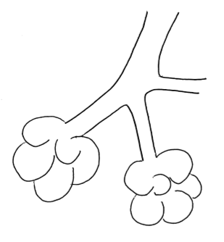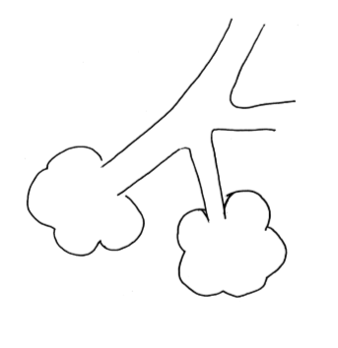
B

A

- Explain which illustration represents the smokers lung and why you made this decision. (2)
B
because the alveolar walls have been damaged

- How will gas exchange be affected? (1)
It will be reduced as the surface area has been reduced

3. Three organisms have had their surface area and volume measured.

- Calculate their surface area: volume ratio and record this in the table below. (3)

 | Organism A | Organism B | Organism C
Surface area cm² | 6 | 600 | 60000
Volume cm³ | 1 | 1000 | 1000000
Surface area : volume ratio | 6 | 0.6 | 0.06

- Which organism will receive all the oxygen it requires through diffusion through its outer surface? (1)
A
- Explain which organism is most likely to receive little or no oxygen through its outer surface. (2)
C because the surface area to volume ratio is the smallest.
It will have a specialised gas exchange surface like lungs or gills to increase the surface area for gas exchange.
B. Human circulation
1. The diagram below shows the structure of the heart.
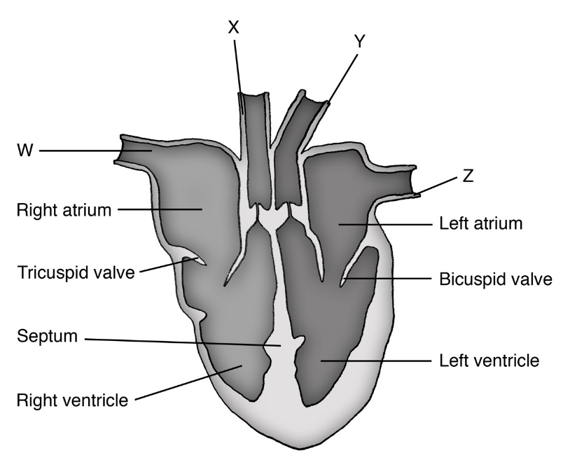

- Name and describe the function of the parts W, X, Y and Z. (4)
- W – vena cava – sends deoxygenated blood into the heart
- X – pulmonary artery – delivers deoxygenated blood into the lungs
- Y – aorta – sends oxygenated blood to the body
- Z – pulmonary vein – delivers oxygenated blood into the left atrium/left side of the heart
b. The heart is described as a ‘double pump’; explain why two separate circulation systems are needed. (2)
- The right-side pumps blood to the lungs for gas exchange
- The left-side pumps oxygenated blood to the rest of the body
c. Look at the bicuspid valve on the diagram of the heart. This is one of the atrioventricular valves.
Using this information, explain the function of this valve. (2)
- Prevents blood from flowing from the left ventricle into the left atrium
- Left atrium
d. Janeth was carrying out a heart dissection. He was trying to work out which ventricle was the one which pumps blood around the body.

Explain one observation he could make which would help him decide. (1)
- Thicker ventricle wall = left side
- Bicuspid valve only has two flaps
- Or other appropriate answer
C. Aerobic and anaerobic respiration
1. Describe the differences between anaerobic and aerobic respiration in animal cells. (4)
Four from:
- Oxygen is required in aerobic respiration but not in anaerobic respiration.
- Carbon dioxide and water are the products of aerobic respiration. Lactic acid is the product for anaerobic respiration.
- Glucose is completely oxidised in aerobic respiration and only partially oxidised in anaerobic respiration.
- The efficiency of energy transfer is high in aerobic and low in anaerobic respiration.
- Aerobic respiration takes place in the mitochondria and anaerobic respiration occurs in the cytoplasm.
2. ‘Some uses for the energy transferred from respiration are the same in plants and animals and some are different.’ Explain what this statement means. (3)
- Plants and animals both use the energy to build larger molecules from smaller ones e.g. proteins from amino acids.
- Animals also use the energy to enable muscles to contract and bring about movement.
- Some animals use the energy to maintain a steady body temperature in a cold environment.

3. Explain why the mitochondria in cells are important. (3)
- Cells require energy for metabolic functions
- Mitochondria are the site of aerobic respiration
- Energy is released from aerobic respiration
4. Suggest how the rate of respiration in an animal cell might change over a typical 24 hour period. (2)
The rate will be higher during the day and when the body is active. At night, the body requires less energy as it is less active and so the rate is reduced (but never stops).
5. A patient was linked to a heart rate monitor whilst doing exercise.
a) Explain why the patient’s heart rate increased from 75 beats per minute to 120 beats per minute. (5)
Any 5 points from:
- To increase blood flow
- To supply more food/sugar/glucose for respiration
- To supply more oxygen for aerobic respiration
- To supply energy to muscles at a faster rate
- To enable muscles to contract faster/work harder
- To remove lactic acid
- To remove carbon dioxide
- To remove heat

b) The doctor was given a print out which showed the patient had a resting heart rate of 75 beats per minute and a cardiac output of 8 litres per minute.

Calculate the stroke volume for this patient in ml per beat. (3)
Stroke volume= cardiac output ÷ heart rate (1)
= 8 ÷ 75 = 0.11 litres per beat (1)
= 0.11 x1000 = 110 ml per beat (1)
3 marks for correct answer and no working
7. Extended response question:
Wild dogs tend to rely on stamina and wear down their prey with a long chase which can be up to an hour. Their muscles fatigue slowly as they pace themselves.
This graph shows how much energy is being produced for muscle cells from anaerobic and aerobic respiration during exercise.

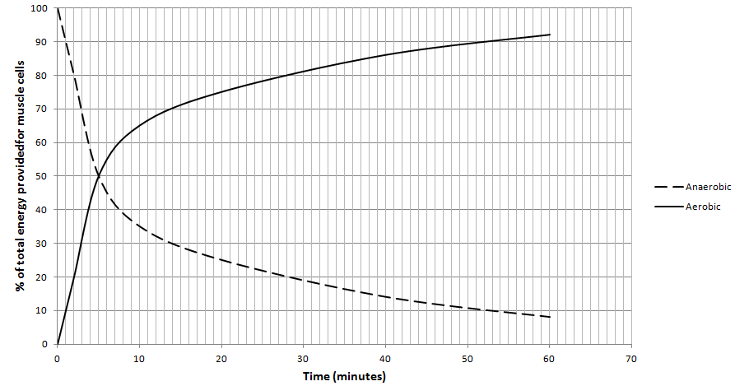

Using the information provided and your own knowledge describe and explain how energy is being transferred to the muscles in the dog at the start, middle and end of a 60 minute hunt. Include word equations in your answer. (6)
Level 3 (5-6 marks)
A detailed and coherent answer which considers a range of points, correct word equations for aerobic and anaerobic respiration stated and/or an understanding shown in the answer, quotes relevant data from the graph and comes to logical conclusions.

Level 2 (3-4 marks)
An attempt to describe relevant points which come to a conclusion. The correct word equations are included. The use of data may be inconsistent at times.

Level 1 (1-2 marks)
Discrete relevant points made. The logic may be unclear and the conclusion if present may not be consistent with the reasoning. Use of data is inconsistent and at times inaccurate.

Biology content

Quotes correct word equations for anaerobic and aerobic respiration

Dog:
Start of hunt dog gets most of its energy from anaerobic respiration.
By the middle of the hunt – 25 minutes the dog’s muscles are mostly using energy released from aerobic respiration – 77% with some energy still coming from anaerobic respiration (27%).
By the end of the hunt at 50 minutes only 10% of the energy used is coming from anaerobic respiration.
The dog can run for long periods of time as the energy it uses is coming mainly from aerobic respiration. This produces more energy per glucose molecule than anaerobic respiration and the accumulation of lactic acid is minimised.

8. An experiment was set up to investigate the rate of respiration by woodlice. Two identical pieces of apparatus were used. In tube A, 5 woodlice were placed on the gauze tray and in tube B, 5 glass beads of a similar size were added.
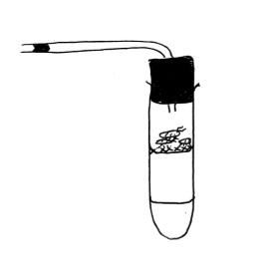
Coloured ink in a glass capillary tube
Potassium hydroxide solution
Woodlice/Glass beads on a gauze tray
10 cm ³ of potassium hydroxide solution was used in each tube to absorb carbon dioxide.
A drop of coloured ink was introduced into both the capillary tubes and the position marked with a permanent marker on the glass. The tubes were left for one hour and then the position of the ink remarked.
Tube | Start position of ink mm | End position of ink after 1 hour mm
A | 2 | 12
B | 3 | 3
- Explain what must have caused the movement of the ink in tube A? (2)
The woodlice respired using up oxygen and producing carbon dioxide which is absorbed by the potassium hydroxide solution so the coloured ink was drawn further along the tube. This did not occur in Tube B because the beads did not respire.
- Why was a gauze tray used to suspend the woodlice/beads? (2)
To prevent the woodlice falling into the solution.
To enable free movement of gases.
- Why are glass beads used in tube B? (1)
To occupy the same space as the woodlice so both tubes contain the same amount of air at the start.
- What other variable must be kept constant to ensure this is a controlled investigation? (1)
Temperature (or any other appropriate control not already mentioned).

